Stick Pull Game

Subject: Mathematics Creators: Ashley Kimberly and Harley Weston
Strand: Number Grade: 6
Content (topic)

Percentages
Outcomes  N 6.5 Demonstrate understanding of percent (limited to whole numbers to 100) concretely, pictorially, and symbolically. | Indicators  N 6.5a: Observe and describe examples of percents (whole numbered to 100) relevant to self, family, or community, represent the percent concretely or pictorially (possibly physically), and explain what the percent tells about the context in which it is being used.  N 6.5b: Solve situational questions, and provide justification for possible decisions, using whole0numbered percents to 100.  N 6.5c: Create and explain representations (concrete, visual, or both) that establish relationships between whole number percents to 100, fractions, and decimals.
Lesson Preparation
Equipment/materials:
- 30 cm of dwelling that has a 2 cm diameter.
- Crisco or lard.
- Cardboard where participants will be participating in the stick pull.
- A towel or washcloth.
- A copy of the score sheet for each pair of students.
Presentation
Development
- Games were common among the different Aboriginal groups of North America and were often given or traded between groups. Give your students the PowerPoint presentation, which provides information on Aboriginal games, both traditional and modern day games. Games of chance could last for hours and were played frequently. Stick games and hand games are relatively simple games that may involve chance, strength and skill.
- The sticks for this game were traditionally made from spruce or pine trees, the stick were approximately 25 cm long, with a diameter of 2.5 cm. The stick in the diagrams in Appendix A is a 30 cm length of 2 cm diameter dowelling.

Rules of Play
- A pair of students stands shoulder width apart with the right foot of one participant touching the right foot of the other participant. (Fig 1)
- Students will need to then extend their right arm to their waist and open their hands. The arm must fully extended and straight. (Fig 2)
- Students must then keep their hands open so that one of the other students in their group can place the dowelling into position. (Fig 3)
- When the dowelling is in position the students need to grip it with their hands at equal distance from the center mark. (Fig 3)
- On a signal, the students begin to try and pull the stick out of each other’s hand. Students cannot jerk or twist the stick or bend the arm during the stick pull. (Fig 4)
- The students must keep their head and shoulders straight to ensure that the range of motion during the pulling is straight. The winner is the student who is pulls the stick from the opponent’s hand.
- Arrange your students into pairs where the two students in each pair are approximately the same height and strength. Divide your class into groups where each group consists of three or four of the pairs. Give each group a dowel, some Crisco and a towel or washcloth.
- On the floor, place cardboard where the participants will be playing the game in order to prevent the lard or Crisco from getting on the floor.
- Have each group grease the dowelling with Crisco or lard as evenly as possible to create a slippery surface.
- Have each pair of students put their names on a score sheet.
- Have each pair of students use their right hands and play the stick pull game 4 times, called the 4 Pull Games on the score sheet. Have someone in the group record, on the score sheet, the number of times each student won.
- Have each pair of students use their right hands and play the stick pull game 5 times, called the 5 Pull Game on the score sheet. Record on the score sheet the number of times each student won.
- Have each pair of students repeat the 4 Pull Games and the 5 Pull Game but this time using their left hands. Have the students clean up using the towel or washcloth.
- Have each pair of students complete their score sheets by calculating the percentages. Have the students discuss techniques they used, for example expressing a fraction as a decimal, writing equivalent fractions or multiplying the numerator and denominator by a whole number that results in a denominator of 100.

Appendix A

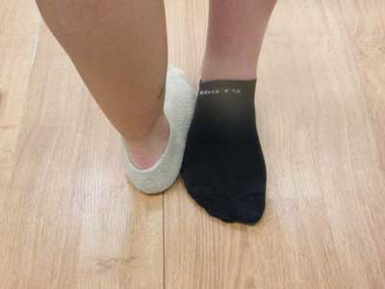
Fig 1

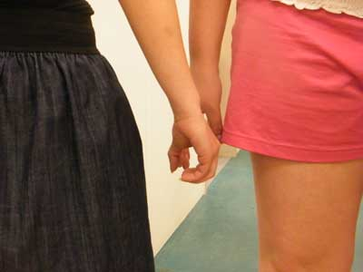
Fig 2

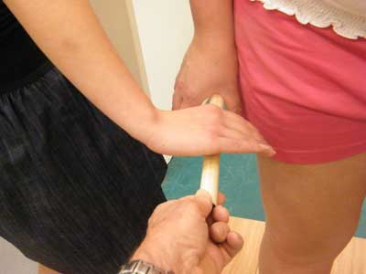
Fig 3

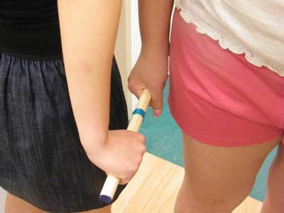
Fig 4

Score Sheets

Right Handed

 | Name | Name
4 Pull Game
Number of wins
Percentage wins
Percentage losses
5 Pull Game
Number of wins
Percentage wins
Percentage losses

Left Handed

 | Name | Name
4 Pull Game
Number of wins
Percentage wins
Percentage losses
5 Pull Game
Number of wins
Percentage wins
Percentage losses

